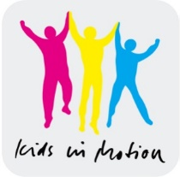
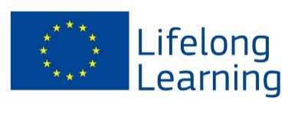
With the support of the
Lifelong Learning Programme
of the European Union

Needs analysis

„Kids in Motion“

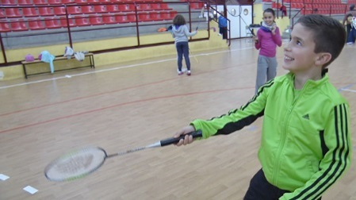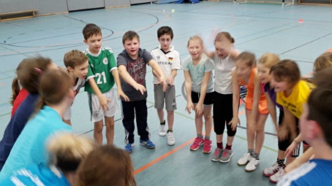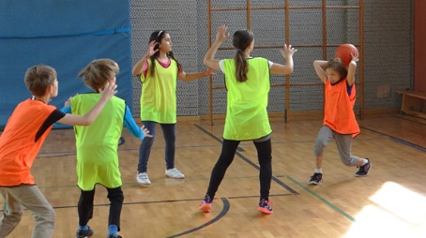

INTRODUCTION
The KIM project needs analysis is based primarily in analyzing the schools system of each of the KIM project country partners. The KIM project needs to know each country school system first, to successfully organize the implementation of the KIM project school physical activity intervention. The main objective is to establish the current resources and needs for the project in the partner countries and to incorporate them into the program development, the curriculum, and the training of the teaching personnel.
The Spanish partners ran this work package. In this needs analyses we will try to show all data from each individual country in a comparative way. I.e. we will present all data in tables, in which each row or column will represent each country..

AIM AND RESEARCH QUESTIONS OF THE NEEDS ANALYSES
The need analysis persue the following aims:
- To collect data form each country school system
- To collect data from each country physical education system
- To collect data from each country school infrastructure and conditions
- To collect data on the implementation (within school hours or after school hours)
All four aims are needed to successfully design and organize the KIM school interventions in different countries.

The specific research questions are:
- Can we implement the KIM sport programme in exactly the same way among countries?
- Which adjustments need to take place in each country to assure a good response and adherence to the KIM program?
- Can we implement the KIM sport programme in the school hours (intra-curricula) or after school hours (extra-curricula)?

METHODOLOGY
The methodology of the KIM needs analyses was done by a descriptive study of the data provided by each country partner.
How was the empiric research executed?
The empiric research was conducted in a descriptive way. Data were collected by questionnaire (see appendix 1) administered to each country partner. The country partner, at the same time, administered the questionnaire to PE teachers in the country and to the school principal to collect specific data. Questionnaires were filled in and returned to the country partner responsible, who after checking all data was completed, sent a summary of the data to the Spanish partner.
The questionnaire had three main sections divided into:
school system, physical education, infrastructure and conditions and when to implement it.
Each of this sections will be analyzed seperately in the results section.

REPORT OF THE NEED ANALYSIS
The results are divided into two main sections:
- Summary of the need analyses of the respective partner countries
- Recommendations for the adaptation of the sport programme realization

1 SUMMARY OF THE NEED ANALYSES OF THE RESPECTIVE PARTNER COUNTRIES
The results will be presented in four tables, each of one representing one of the four sections of the questionnaire. In Table 1 we can observe questions and answers related to the school system, table 2 will focused on the physical education from each country; table 3 will provide data on infrastructure and conditions and table 4 is focused on the possibility to implement the project within school hours or after school, i.e. viability. All data is presented by each country and specifically, from the schools chosen by each country to participate in the KIM project.

Execution of a need analysis in the field of school
In table 1 we can see that all schools selected for the KIM project, include students at the age of 9-10yrs old, as students at primary school. This is the age in which the KIM project will be focused. All countries reported to have similar amount of teaching hours. They reported to have between 4-5hr/day and 20-25hr/wk of lectures. All country schools have a continuous morning timetable, except from Spain and Slovenian, who offer also an afternoon timetable in case students stay at school for lunch. School terms and holidays are not exactly the same among countries, therefore, the KIM project will have to bear this in mind when setting the intervention starting and finishing dates.
Table 1: Execution of a need analysis in the field of school.
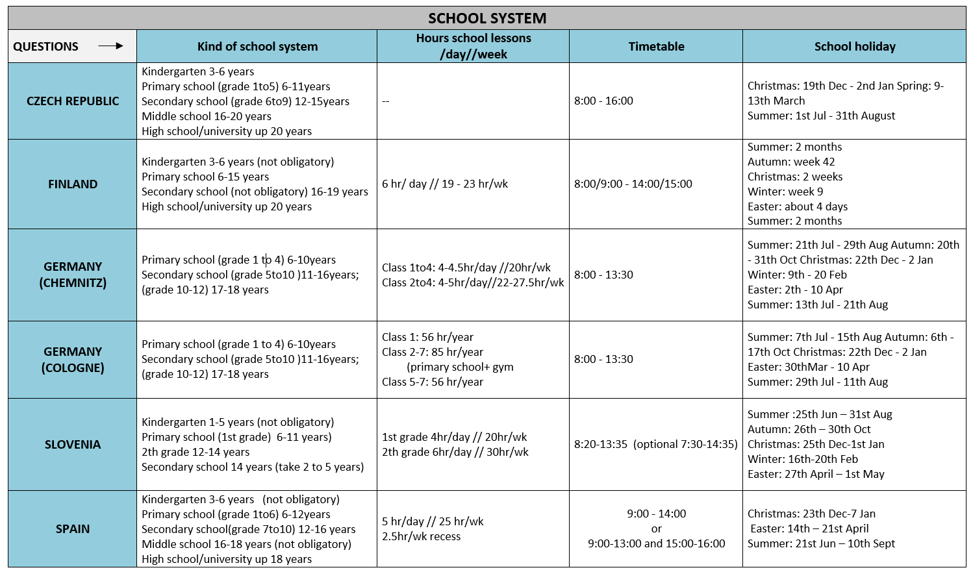

Execution of a need analysis in the field of Physical Education
In Table 2 we can observe questions and answers related to the physical education system of each country. All countries reported to offer 2hr/wk of compulsory physical education except from Slovenia who reported to offer more time (3hr/wk). In relation to sport specific education, all countries seem to focus their physical education in playing games and learning global movements, except from Czech Republic, who reported teaching specific sport education. As we can see in the third column of the table, sport variety is very wide and different among countries. Voluntary extra sports lessons are normally set by school.
We can see differences among countries: Finland includes the option of extra physical education together with music, handcraft and drawing; Slovenia offers optional sport including programs such as: sport for health or sport for relaxation. The rest of the countries offer opportunities in the afternoon as extracurricular classes, or provide active recess time. The only two countries that provide physical education program for specific risk groups (ie. Overweight, obesity…) are Slovenia and Finland, the rest seem to offer the same PE program to all children. Czech Republic reported to offer integration PE programs. Spain does not provide specific physical education extracurricular program. Most of the countries reported to organize activities with some external organization as clubs and other institutions.
These data are important because it seems that in some countries there is a more specific physical education programme and therefore the KIM project can be seen as unique and different. However, in other countries, because of the different culture in physical education, it can be seen only as another sport programme.
Table 2: Execution of a need analysis in the field of Physical Education.
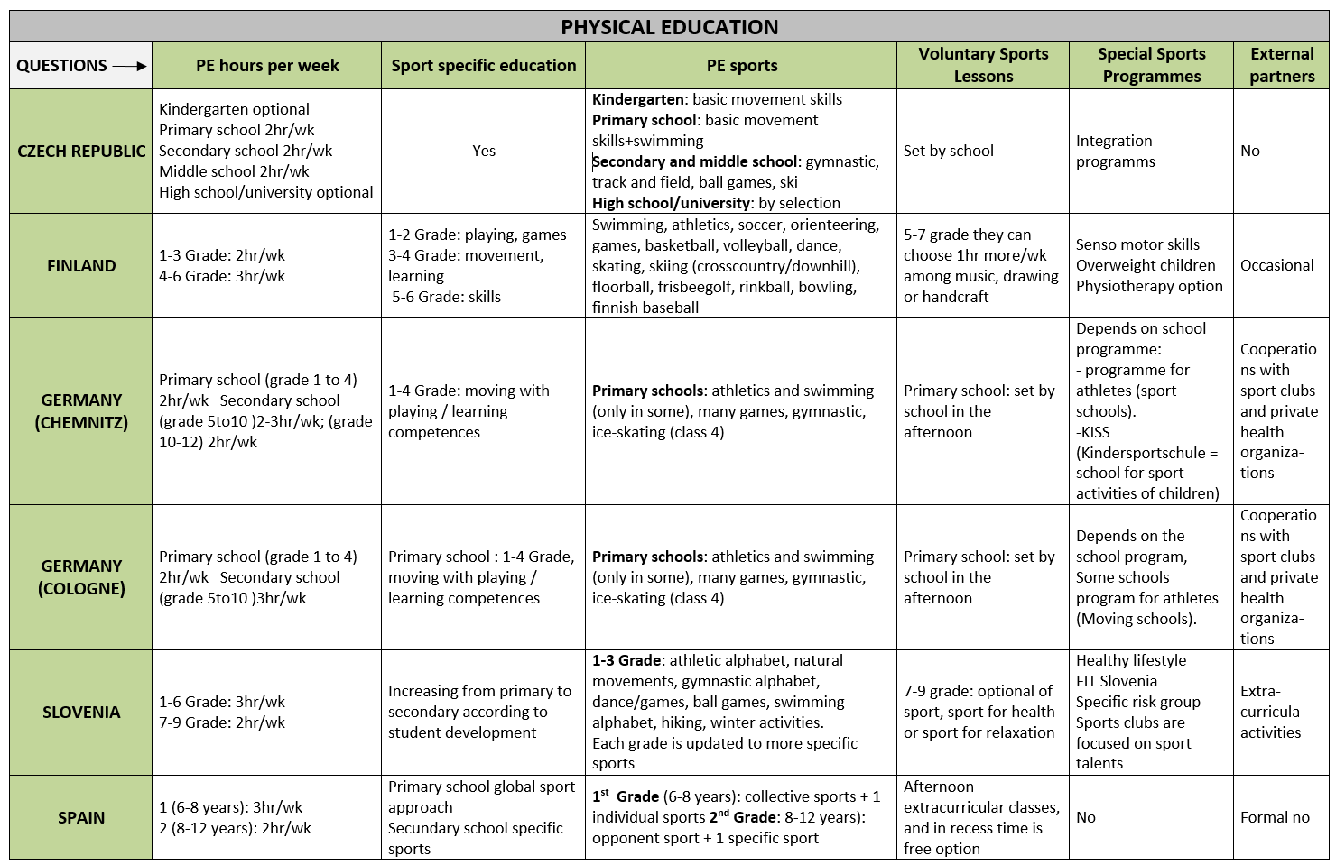

1.3 Execution of a need analysis in the field of infrastructure and conditions

In Table 3 we can observe questions and answer regarding the infrastructure and conditions from each country. To start the KIM project in each individual country, permission is needed mainly from the primary school principal. If KIM project is going to be delivered within the school curricula, the ministry of each country will have to provide permission, which is very unlikely to happen. Main physical education curricula are defined by the Ministry of Education in each country but schools have some freedom for including some specific changes. If the new specific content of sport included by the school want to be certify, it needs to be done by the ministry. In all countries, all PE teachers have specific education for PE at primary school, except from Germany. These results are very important for the implementations of the KIM project.
Perhaps, this information is very important for the implementation of the sport programme. Can a primary school teacher lead the KIM sportprogramme? Or, do we need a Sport Sciences teacher?
One thing we know is that a common methodology to run the KIM project is necessary.

Table 3: Execution of a need analysis in the field of infrastructure and conditions
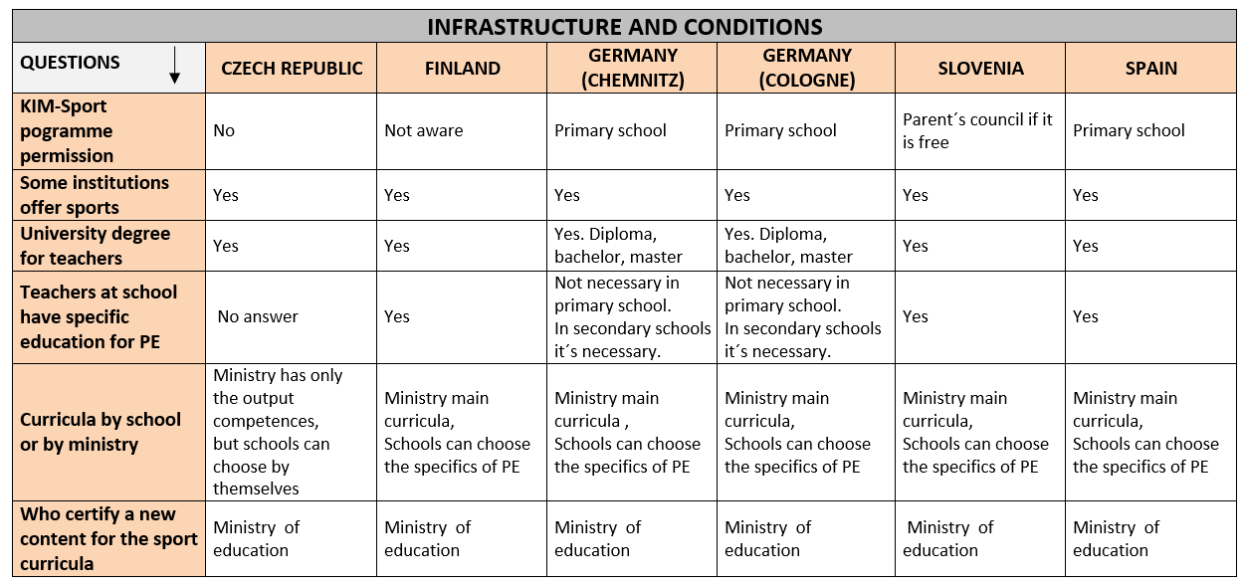

1.4 Execution of a need analysis in the field of viability

The following section is about the viability of the KIM project according to when to implement it (see table 4).
It seems that countries like Check Republic and Spain, who have a more sports specialization approach, need to incorporate KIM in an easier way. I.e. providing finance, or a similar cost than the other sports activities. It seems that KIM needs to be implemented with a new philosophy than the one used untill now. This can be a plus but also a barrier. Therefore, KIM project could be implemented at an earlier age, as Spain stated, or with EU financial help.
Other countries such as Finland and Slovenian with a wider offer of sports activities have implemented it during school hours outside the curricula.
It seems that the KIM project was well accepted due to its specialty for the gifted and more motivated children.

Table 4. Execution of a need analysis in the field of viability
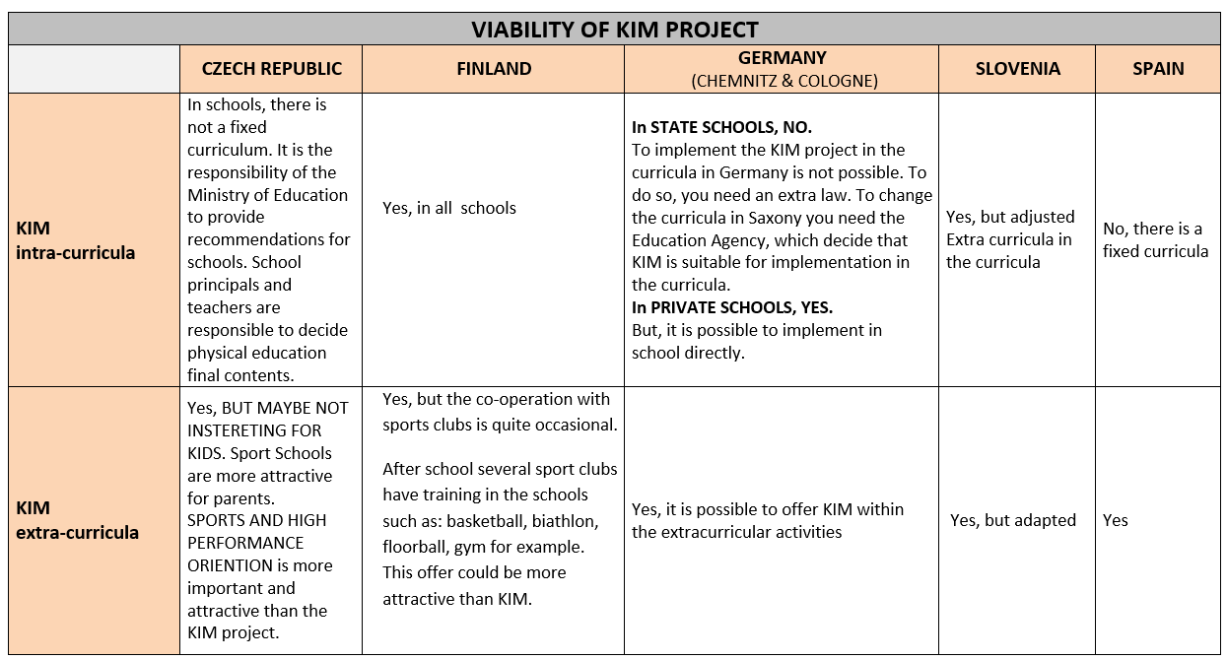

2 RECOMMENDATIONS FOR THE ADAPTATION OF THE PROJECT REALIZATION

From the need analysis presented by the spanish partner and a discussion of the similarities and the differences among countries the partner draw the following conclusions for the implementation of the KIM sport programmes in primary schools (Fig. 1).
The KIM project is doable in all selected schools, all schools have a group of 9-10 years old students. Pre-conditions of the choosen students should be a basic enthusiasm for sport and sufficient motor skill. But it is also possible to choose all students of a class for the programme. For student who have special conditions such as chronic diseases or obesity special sport programmes could be more suitable if offered in the school.
The specific needs for the KIM projects are:
    - KIM project can be done primarily as an extra-curricula activity assuring permission from the school principal.
Running KIM project within school curricula needs to be decided according to each country curricula situation.
    - Terms are different among countries and therefore staring dates and finishing dates are country specific.
    - Sports chosen will be the ones that require less infrastructure,
swimming and skating are not considered because of this reason.
    - Most of the countries have PE teachers in primary school with specific education for PE.
    - If schools offer many different extra curricula activities, the weekly frequency of the KIM program, may vary. I.e. In Spain, it is likely it will run twice (2 days) per week, In Slovenia, Finland, Germany and Check Republic it is plan to run once a week.

Fig. 1: The implemention of the KIM sport programme in primary schools.
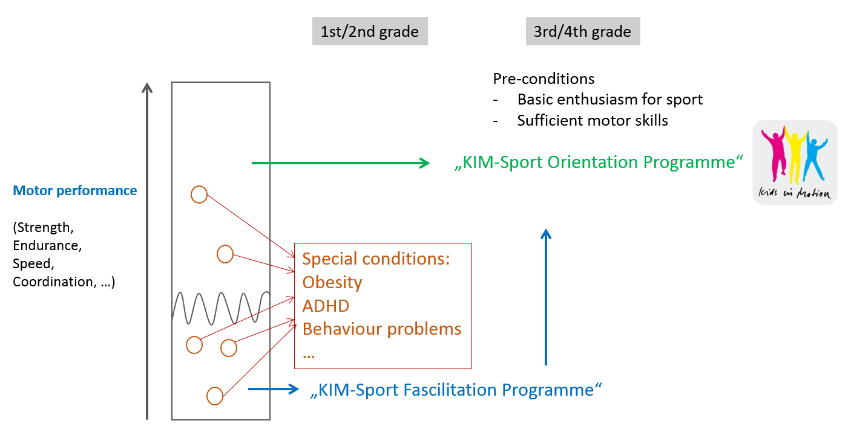

The recommendations regarding the viability of the sport programme in each country are as follows:
Czech Republic:
In the Czech Republic it is necessary to reach schools with the project already prepared. The project must be for the school financially or otherwise interesting (rentals, pay teachers, sports equipment free of charge etc.). Addressing schools in the Czech Republic by email or telephone has a minimal impact. It is preferred face to face meetings.
Finland:
Methodology needs to be improved.
Germany:
Extracurricular offer ofKIM programme. Could be offered to the more skilled students as a specific programme.

Slovenia:
Methodology needs to be improved.
Spain:
Extracurricular offer of KIM programmes, but because of the wide offer of sports schools available, KIM could be very useful as a pre sport specialization.

The KIM sport programme will be performed in primary schools in Spain, Czech Republic, Slovenia and Germany. The specific recommendations for the implementation of the KIM sport programme in the pilot schools are:
    - Organization of a meeting with the School principal to plan:
  - Meeting to inform parents about KIM project
  - Discuss with parents the weekly frequency of KIM program
  - Each country needs to organize the timetable according to school terms and country/local holidays.
    - Swimming and skating will not be included into the program due to practical reasons.
We decided to include dancing instead.
Therefore, we need to create a new didactic unit in dancing.
    - Multiplayers and school PE teachers will need further training. The KIM project practical training is planned to be organized in Slovenia. This training is very important because not all teachers will have the same education. Primary school teachers need some sports background and the right methodology.
    - Extra-curricula KIM project could fit better than in the curricula. Using school hours is not an option in all countries. KIM project needs to be adjusted for each country.
    - When the sports specialization is offered to school children at an early age, it is important to explain the KIM philosophy carefully to parebta, to make them aware about the utility and relevance of the KIM project. Moreover, in some countries, the idea of starting at the age of 8 instead that at the age of 9 is considered as an option for the same matter.
    - KIM project is offered to the most motivated children but in some countries, they are also the most competent ones. This situation makes the group unique and special. Whereas in other countries, this is not the reality. KIM project needs to clarify who is targeted for.

The continuity of KIM sport programmes in schools without EU financial support is always dependent on the will and individuality of physical education teachers and school management. This problem will be adresses in the sustainability plan.

